ETL PROJECT
Goal: Pull live data from a specific database, create your own database, load live database, automate the process

-- For this project I will be exploring EPL database to get live updates as regards
- Standings
- Fixtures
- Goal Scorers

I had to find an website that allows me get access through api keys and I resorted to football-data.org

Pulling data for Standings; Using the API key I was able to extract data for EPL standings which I will load into my PostgreSQL database
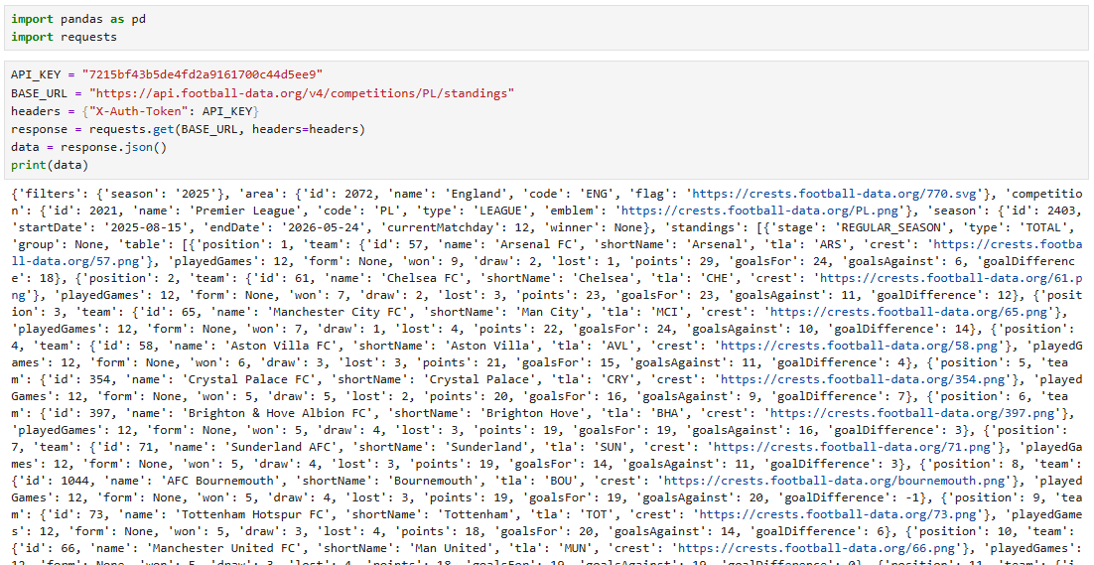

I converted and filtered the data to allow only data for standings move to my database

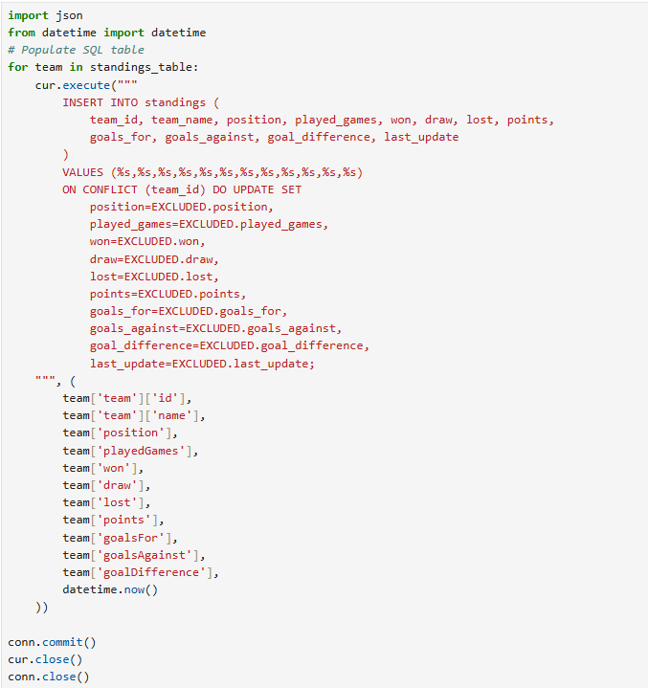

I will repeat the same steps for fixtures and goal scorers.. Having done that I now have a live database inside my own database. I will go ahead to automate the process for each table. Which allows new data entry without having to open SQL
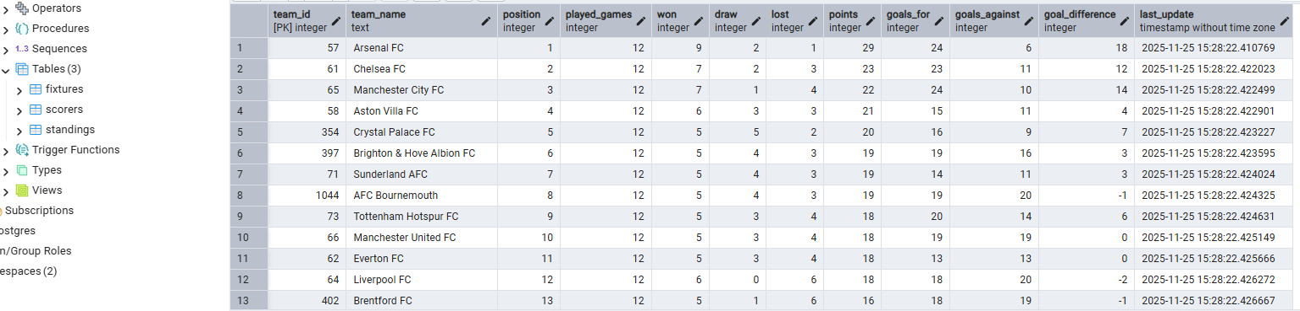
The next step is to automate the process so that whenever the original database is updated mine gets updated automatically as well, I wrote a single python script that automates all tables and ran it successfully on jupyter notebook.
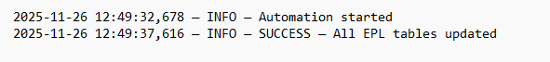
The next step is to migrate my current data from local on premises DB to a cloud DB, this way it’s easier to give room for collaboration. I would expect
- On premises database (postgresql)-- recieves updated from live database
- Cloud database (Neon Postgresql)

Using the dump.sql method, I created a dump file from our on prem data base, and migrated the data to my cloud database on Neon through psql terminal.
- Connection was created which read my cloud db as the target
- Same connection read my dump file from my local pc file folders and effected the dump succesfully
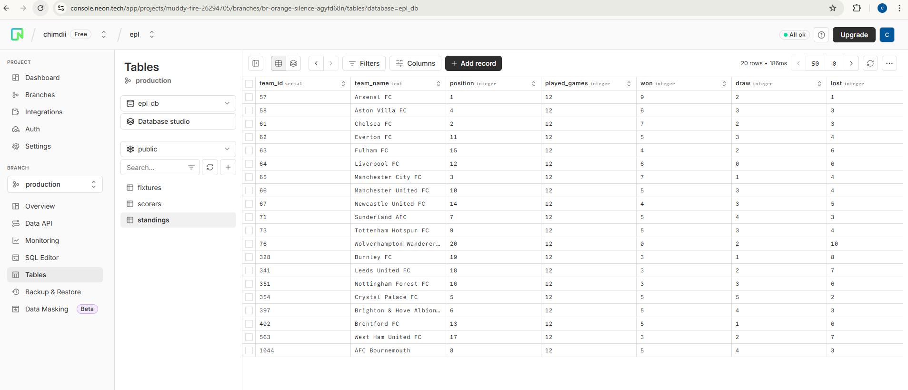

Now we have a local and cloud database we can feed live data to, the next step is to write an automation script for the cloudDB, Which I did and it worked succesfully. The cloud database is available for case scenarios where we have to collaborate

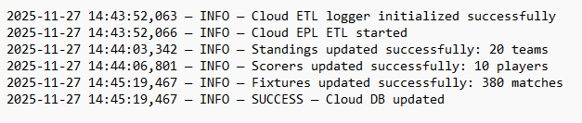

The next step is to upload our scripts on github and schedule automation.

